MEMORANDUM OF UNDERSTANDING (MoU)
BETWEEN
KAYDM STRAUS LIMITED
AND
CAUFERO GROUP
This Memorandum of Understanding (“MoU”) is made and entered into this ___ day of December, 2025,

BETWEEN:
Kaydm Straus Limited, a company duly incorporated under the laws of the Republic of Ghana, acting herein through its Chief Executive Officer, Mr. Augustine Kanton, (hereinafter referred to as “Kaydm Straus Ltd”),
AND
Caufero Group, a business entity duly registered under the laws of the Republic of Ghana, acting herein through its authorized representative, Mr. Cyril Amegah, (hereinafter referred to as “Caufero Group”).
Kaydm Straus Ltd and Caufero Group shall hereinafter individually be referred to as a “Party” and collectively as the “Parties”.

1. PURPOSE OF THE MoU
The purpose of this MoU is to define the terms and understanding under which Caufero Group shall design, develop, deploy, and support a digital gifting platform for Kaydm Straus Limited.

2. SCOPE OF WORK
Caufero Group shall be responsible for the following deliverables:
- Design and development of a web-based portal for the gifting platform.
- Development of Android mobile application.
- Development of iOS mobile application.
- Integration and deployment of a USSD code system to support gifting transactions.
- End-to-end system testing to ensure full functionality and security.
- Deployment of the system into a live production environment.
- Provision of technical support after deployment.

3. PROJECT TIMELINE
- The project shall commence upon signing of this MoU.
- The entire system shall be fully completed, tested, and functional on or before April 2026.
- Any variation to the timeline shall be mutually agreed upon in writing by both Parties.

4. FINANCIAL OBLIGATIONS
- Kaydm Straus Limited agrees to pay Caufero Group a total project cost of Sixty-Nine Thousand Eight Hundred Ghana Cedis (GHS 69,800.00).
- Payment shall be made in instalments, structured to cover the development period of the project.
- The instalment schedule shall be mutually agreed upon by the Parties and may be revised by written consent.

5. TECHNICAL SUPPORT AND MAINTENANCE
- Caufero Group shall provide technical support upon completion and deployment of the platform.
- The scope and duration of technical support shall include system monitoring, bug fixes, and general maintenance.
- Any extended maintenance or upgrades beyond the agreed support scope may be subject to additional negotiation.

6. INTELLECTUAL PROPERTY
- Upon full payment of the agreed project cost, all intellectual property rights relating to the developed platform shall vest in Kaydm Straus Limited.
- Caufero Group may retain the right to reference the project for portfolio and marketing purposes, subject to confidentiality obligations.

7. CONFIDENTIALITY
Both Parties agree to treat all proprietary, technical, financial, and business information exchanged under this MoU as confidential and shall not disclose such information to third parties without prior written consent.

8. NON-BINDING NATURE
This MoU expresses the good faith intentions of the Parties and shall serve as a guiding framework. Except for clauses relating to confidentiality and payment obligations, this MoU does not create a legally binding partnership unless followed by a formal contract.

9. GOVERNING LAW
This MoU shall be governed by and construed in accordance with the laws of the Republic of Ghana.

10. TERMINATION
- Either Party may terminate this MoU by providing written notice to the other Party.
- In the event of termination, all completed work shall be assessed and payments adjusted accordingly.

11. AMENDMENTS
Any amendment to this MoU shall be made in writing and signed by both Parties.

12. SIGNATURES
IN WITNESS WHEREOF, the Parties hereto have executed this Memorandum of Understanding on the date first written above.
For Kaydm Straus Limited
Name: Mr. Augustine Kanton
Title: Chief Executive Officer
Signature: ________________________
Date: _____________________________

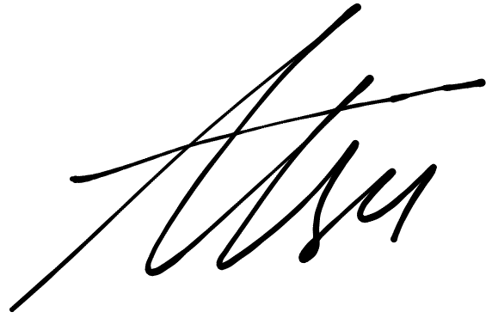
For Caufero Group
Name: Mr. Cyril Amegah
Title: Chief Executive Officer
Signature: _________________________
Date: ______28th December, 2025______

